**PG-DAC Sep 2021 Assignment 1**

**Date: 21/09/2021**

**Submission Date: 23/09/2021**

**1. Write a Java program to print 'Hello' on screen and then print your name on a separate line.**

Expected Output :

Hello

Alexandra Abramov

**2. Write a Java program to print the sum of two numbers.**

Test Data: 74 + 36

**3. Write a Java program to divide two numbers and print on the screen.**

Test Data : 50/3

Expected Output : 16

**4. Write a Java program to print the result of the following operations.**

Test Data:

a. -5 + 8 * 6

b. (55+9) % 9

c. 20 + -3*5 / 8

d. 5 + 15 / 3 * 2 - 8 % 3

Expected Output :

43

1

19

13

**5. Write a Java program that takes two numbers as input and display the product of two numbers.**

Test Data:

Input first number: 25

Input second number: 5

Expected Output :

25 x 5 = 125

**6. Write a Java program to print the sum (addition), multiply, subtract, divide and remainder of two numbers.**

Test Data:

Input first number: 125

Input second number: 24

Expected Output :

125 + 24 = 149

125 - 24 = 101

125 x 24 = 3000

125 / 24 = 5

125 mod 24 = 5

**7. Write a Java program that takes a number as input and prints its multiplication table upto 10.**

Test Data:

Input a number: 8

Expected Output :

8 x 1 = 8

8 x 2 = 16

8 x 3 = 24

...

8 x 10 = 80

**8. Write a Java program to display the following pattern.**

Sample Pattern :

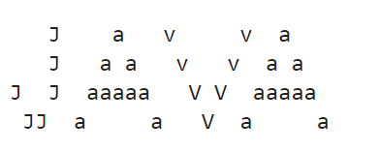

**9. Write a Java program to compute the specified expressions and print the output.**

Test Data:

((25.5 * 3.5 - 3.5 * 3.5) / (40.5 - 4.5))

Expected Output

2.138888888888889

**10. Write a Java program to compute a specified formula.**

Specified Formula :

4.0 * (1 - (1.0/3) + (1.0/5) - (1.0/7) + (1.0/9) - (1.0/11))

Expected Output

2.9760461760461765

**11. Write a Java program to print the area and perimeter of a circle.**

**(Adding pie as a symbol is remaining)**

Test Data:

Radius = 7.5

Expected Output

Perimeter is = 47.12388980384689

Area is = 176.71458676442586

**12. Write a Java program that takes three numbers as input to calculate and print the average of the numbers.**

**13. Write a Java program to print the area and perimeter of a rectangle.**

Test Data:

Width = 5.5 Height = 8.5

Expected Output

Area is 5.6 * 8.5 = 47.60

Perimeter is 2 * (5.6 + 8.5) = 28.20

**14. Write a Java program to print an American flag on the screen.**

Expected Output

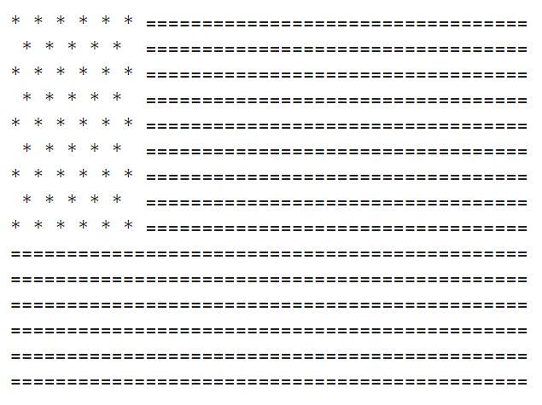

**15. Write a Java program to swap two variables.**

**16. Write a Java program to print a face.**

Expected Output

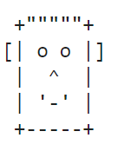

**17. Write a Java program to add two binary numbers.**

Input Data:

Input first binary number: 10

Input second binary number: 11

Expected Output

Sum of two binary numbers: 101

**18. Write a Java program to multiply two binary numbers.**

Input Data:

Input the first binary number: 10

Input the second binary number: 11

Expected Output

Product of two binary numbers: 110

**19. Write a Java program to convert a decimal number to binary number.**

Input Data:

Input a Decimal Number : 5

Expected Output

Binary number is: 101

**20. Write a Java program to convert a decimal number to hexadecimal number.**

Input Data:

Input a decimal number: 15

Expected Output

Hexadecimal number is : F

**21. Write a Java program to convert a decimal number to octal number.**

Input Data:

Input a Decimal Number: 15

Expected Output

Octal number is: 17

**22. Write a Java program to convert a binary number to decimal number.**

Input Data:

Input a binary number: 100

Expected Output

Decimal Number: 4

**23. Write a Java program to convert a binary number to hexadecimal number.**

Input Data:

Input a Binary Number: 1101

Expected Output

HexaDecimal value: D

**24. Write a Java program to convert a binary number to a Octal number.**

Input Data:

Input a Binary Number: 111

Expected Output

Octal number: 7

**25. Write a Java program to convert a octal number to a decimal number.**

Input Data:

Input any octal number: 10

Expected Output

Equivalent decimal number: 8